Bài tập chương 5

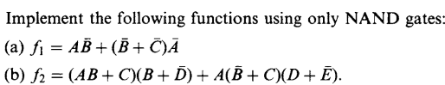Bài 1:

a.

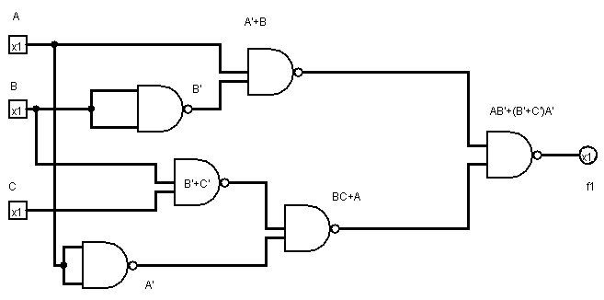

b.

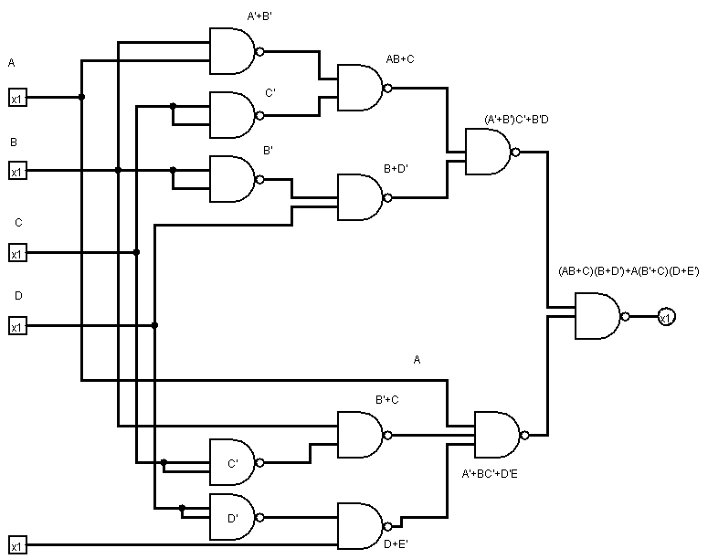

Bài 2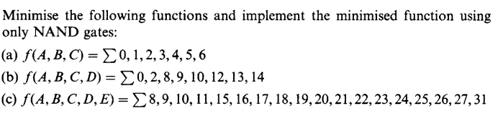



|  |  |  |  |  |
| --- | --- | --- | --- | --- |
| A BC | 00 | 01 | 11 | 10 |
| 0 | 1 | 1 | 1 | 1 |
| 1 | 1 | 1 |  | 1 |

F(A,B,C)=A’+B’+C’

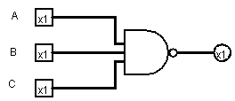

|  |  |  |  |  |
| --- | --- | --- | --- | --- |
| CD AB | 00 | 01 | 11 | 10 |
| 00 | 1 |  | 1 | 1 |
| 01 |  |  | 1 | 1 |
| 11 |  |  |  |  |
| 10 | 1 |  | 1 | 1 |

F(A,B,C,D)=B’D’+AC’+AD’

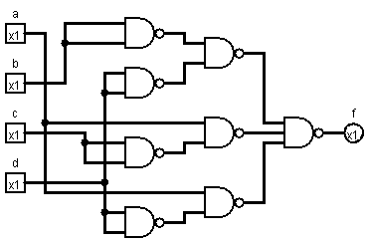

1. F(A,B,C,D,E)=wps(8,9,10,11,15,16,17,18,19,20,21,22,23,24,25,26,27,31)

|  |  |  |  |  |
| --- | --- | --- | --- | --- |
| CD AB | 00 | 01 | 11 | 10 |
| 00 |  |  |  | 1 |
| 01 |  |  |  | 1 |
| 11 |  |  | 1 | 1 |
| 10 |  |  |  | 1 |

E’

E

|  |  |  |  |  |
| --- | --- | --- | --- | --- |
| CD AB | 00 | 01 | 11 | 10 |
| 00 | 1 | 1 |  | 1 |
| 01 | 1 | 1 |  | 1 |
| 11 | 1 | 1 | 1 | 1 |
| 10 | 1 | 1 |  | 1 |

F=BC’ + BDE + AB’

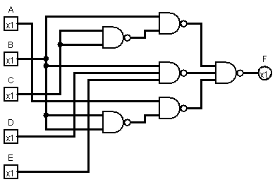

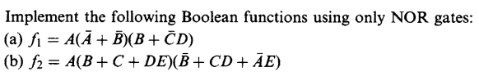Bài 3:

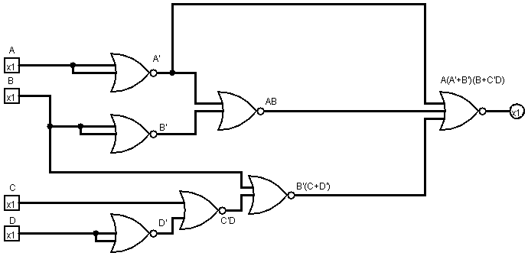

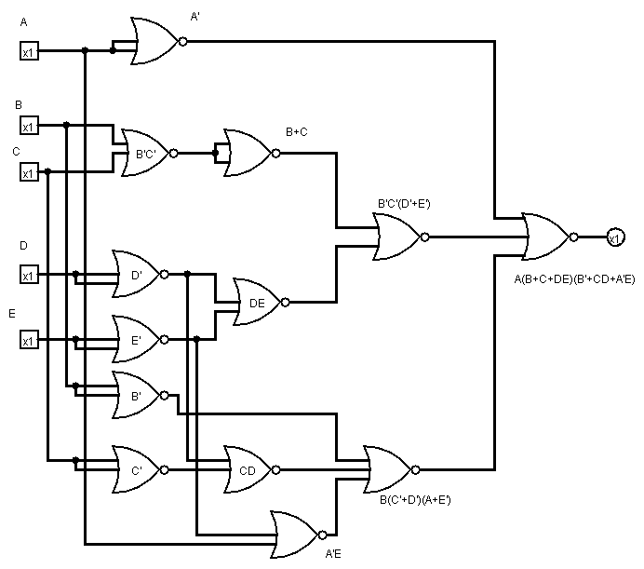

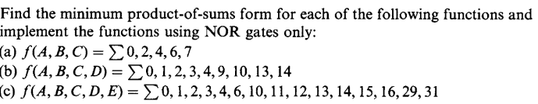Bài 4:

1. F(A,B,C)= wps(1,3,5) = (A+B+C’)(A+B’+C’)(A’+B+C’)=(A+C’)(B+C’)

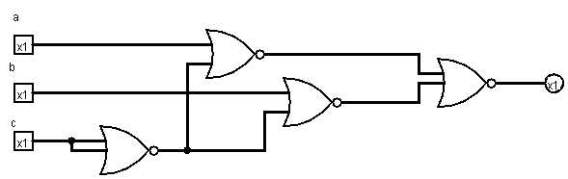

1. F(A,B,C,D)=(5,6,7,8,11,12,15)=(A+B’+D’)(A+B’+C’)(A’+C+D)(A’+C’+D’)

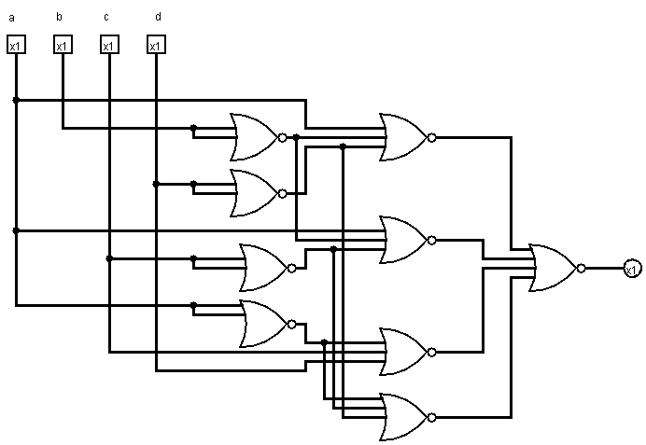

1. F(A,B,C,D,E)=(5,7,8,9,17,18,19,20,21,22,23,24,25,26,27,28,30)=(B+C’+E)(B+C’+D’)(B’+C+D+E)(A’+B)(A’+C)(A’+E)

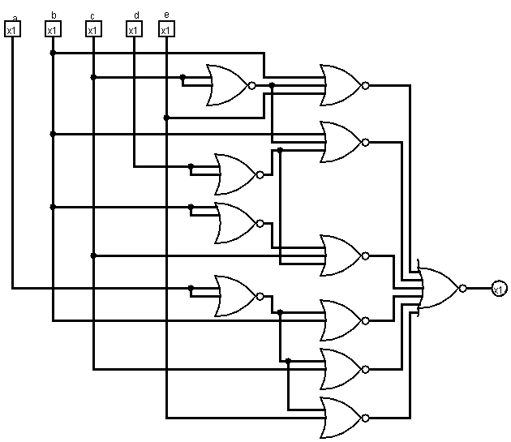

Bài 5: 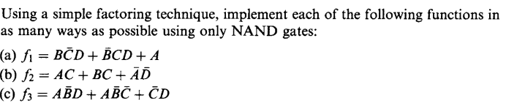

1. F1

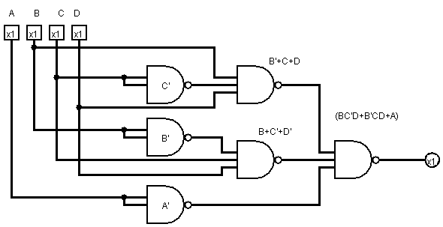

1. F2

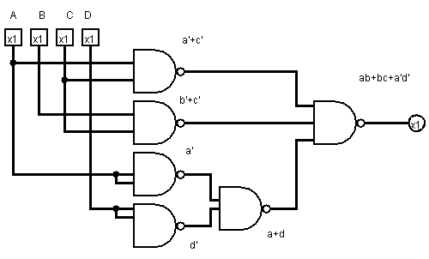

1. F3

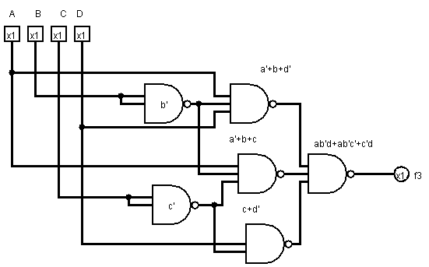

Bài 6: 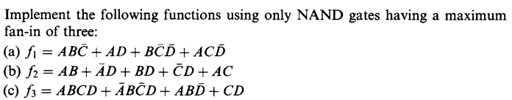

1. F1

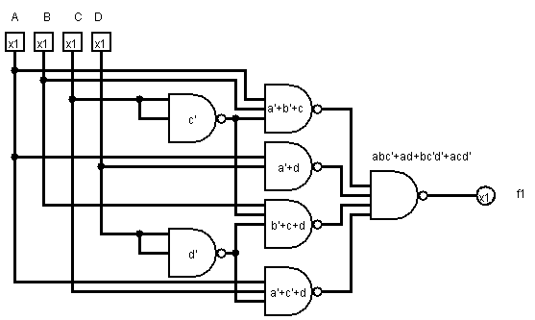

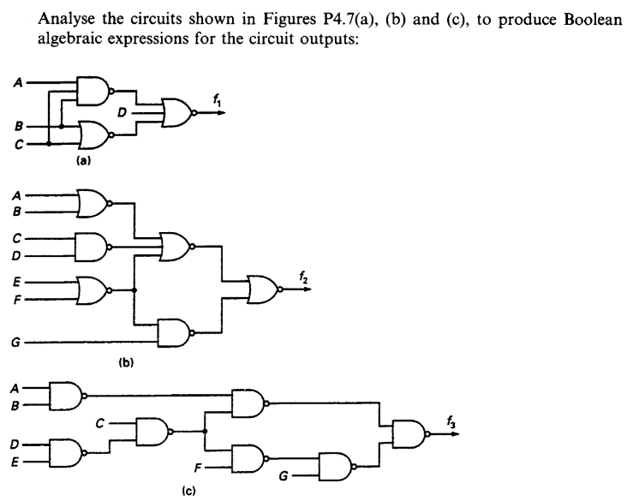Bài 7:

1. F1(A,B,C,D)=((ABC)’+(B+C)’+D)’
2. F2(A,B,C,D,E,F,G)=(A’B’+C’+D’+E’F’)(E’F’G)
3. F3(A,B,C,D,E,F,G)=((D’+E’)C’+F’)G+(A’+B’)DE+C

Bài 8:

1. ABCD’(B+C)
2. A’B’E’F’G+C’E’F’G+D’E’F’G+E’F’G
3. D’C’G+C’E’G+F’G+A’DE+B’DE+C

Bài 9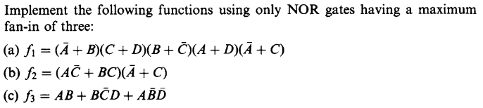:

Bài 10:  
  
  
  
  
   
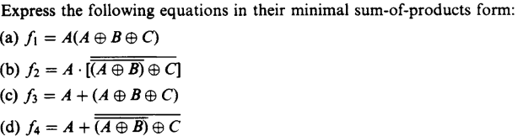a) f1=A(A(B’C’+BC)+A’(B’C+BC’))

=A(AB’C’+ABC+A’B’C+A’BC’)

=AB’C’+ABC

b) f2= A(A XOR B)’ XOR C)’

=A(( A’B’+AB)XOR C)’

= A((A’B+AB’)C+(A’B’+AB)C’)’

=A(A’BC+AB’C+A’B’C’+ABC’)’

=A((A+B’+C’)(A’+B+C’)(A+B+C)(A’+B’+C))

=A(AA’+AB+AC’+A’D’+BB’+B’C’+A’C’+BC’+C’)(AA’+AB’+AC+A’B+BB’+BC+A’C+B’C+C)

=(AB+AC’+AB’C+ABC’+AC’)(AB’+AC+A’B+BC+A’C+B’C+C)

=ABC+AB’C’+AB’C

=AC(B+B’)+AB’C’=AC+AB’

1. F3=A+(A XOR B XOR C)

=

Bài 11

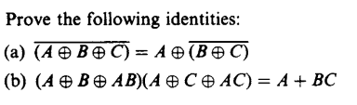

1. (A XOR B XOR C)’

=(A XOR(BC’+B’C))’

=(A(BC’+B’C)’+A’(BC’+B’C))’

=((AB’C+ABC+A’BC’+A’B’C))’

=(A’+B+C)(A’+B’+C’)(A+B’+C)(A+B+C’)

=A’B’C’+A’BC+ABC’+AB’C

=A’(B’C’+BC)+A(BC’+B’C)

=A’(B NXOR C) + A(B NXOR C)’

= A XOR (B XOR C)’ = VP

1. (A XOR B XOR AB)( A XOR C XOR AC)

=((A’B+AB’) XOR AB)(A’C+AC’) XOR AC)

= ((A’B’+AB)AB + (A’+B’)(A’B+AB’))((A’C’+AC)AC+(A’+C’)(A’C+AC’))

=(A+B)(A+C)

=A+AB+BC

=A(1+B)+BC=A+BC=VP